***Console Base Programs***

**Console.Write**

using System;

using System.Collections.Generic;

using System.Linq;

using System.Text;

using System.Threading.Tasks;

namespace Write

{

classProgram

{

staticvoid Main(string[] args)

{

String a;

Console.Write("Enter Your name:");

a = Console.ReadLine();

}

}

**Simple Introduction**

using System;

using System.Collections.Generic;

using System.Linq;

using System.Text;

using System.Threading.Tasks;

namespace Practice

{

classProgram

{

staticvoid Main(string[] args)

{

int age, id;

String name, address;

Console.WriteLine("Enter Your Name Here:");

name = Console.ReadLine();

Console.WriteLine("Enter Your ID here:");

id = Convert.ToInt32(Console.ReadLine());

Console.WriteLine("Enter Your age here:");

age = Convert.ToInt32(Console.ReadLine());

Console.WriteLine("Enter Your Address Here:");

address = Console.ReadLine();

}

}

}

**Array List**

using System;

using System.Collections.Generic;

using System.Linq;

using System.Text;

using System.Threading.Tasks;

using System.Collections;

namespace ConsoleApplication1

{

classProgram

{

staticvoid Main(string[] args)

{

ArrayList al = newArrayList();

Console.WriteLine("Adding some numbers:");

al.Add(45);

al.Add(78);

al.Add(33);

Console.WriteLine("Capacity: {0} ", al.Capacity);

Console.WriteLine("Count: {0}", al.Count);

Console.Write("Content: ");

foreach (int i in al)

{

Console.Write(i + " ");

}

Console.WriteLine();

Console.Write("Sorted Content: ");

al.Clone();

foreach (int i in al)

{

Console.Write(i + " ");

}

Console.WriteLine();

Console.ReadLine();

}

}

}

**Even Odd**

using System;

using System.Collections.Generic;

using System.Linq;

using System.Text;

using System.Threading.Tasks;

namespace EvenOod

{

classProgram

{

staticvoid Main(string[] args)

{

int n;

Console.WriteLine("Enter any Number:");

n=Convert.ToInt32(Console.ReadLine());

if(n%2==0)

{

Console.WriteLine("Number is Even!!!!!");

}

else

{

Console.WriteLine("Number is Odd!!!!!");

}

Console.ReadKey();

}

}

}

**Conversion in Double**

using System;

using System.Collections.Generic;

using System.Linq;

using System.Text;

using System.Threading.Tasks;

namespace Float

{

classProgram

{

staticvoid Main(string[] args)

{

double a, b, div;

Console.WriteLine("Enter 1st Value:");

a = Convert.ToDouble(Console.ReadLine());

Console.WriteLine("Enter 2nd Value:");

b = Convert.ToDouble(Console.ReadLine());

div = a / b;

Console.WriteLine("Result: {0}",div);

Console.ReadKey();

}

}

}

**Four Numbers with their Sum and Average and Calculating Grade**

using System;

using System.Collections.Generic;

using System.Linq;

using System.Text;

using System.Threading.Tasks;

namespace Grades

{

classProgram

{

staticvoid Main(string[] args)

{

float Q, A, M, F;

float sum = 0, avg = 0;

Console.WriteLine("Enter Quiz Marks:");

Q = Convert.ToSingle(Console.ReadLine());

Console.WriteLine("Enter Assignments Marks:");

A = Convert.ToSingle(Console.ReadLine());

Console.WriteLine("Enter Mid Term Marks:");

M = Convert.ToSingle(Console.ReadLine());

Console.WriteLine("Enter Final Term Marks:");

F = Convert.ToSingle(Console.ReadLine());

sum = Q + A + M + F;

avg = sum / 4;

Console.WriteLine("Your Total Marks: {0}", sum);

Console.WriteLine("Your Average Marks are: {0}", avg);

if (avg >= 90 && avg <= 100)

{

Console.WriteLine("Your Grade is A!!!!!!");

}

elseif (avg >= 70 && avg < 90)

{

Console.WriteLine("Your Grade is B!!!!!!");

}

elseif (avg >= 50 && avg < 70)

{

Console.WriteLine("Your Grade is C!!!!!!");

}

elseif (avg >= 0 && avg < 50)

{

Console.WriteLine("Your are Fail!!!!!!");

}

else

{

Console.WriteLine("Average will Never Neagtive or Greater then Zero So there is No Grade!!!!!!");

}

Console.ReadKey();

}

}

}

**New Calculator using string.formate functionality**

using System;

using System.Collections.Generic;

using System.Linq;

using System.Text;

using System.Threading.Tasks;

namespace New_Calculator

{

classProgram

{

staticvoid Main(string[] args)

{

int a, b, sum, sub, mul;

float div;

String O1, O2, O3, O4;

Console.WriteLine("Enter any Number:");

a = Convert.ToInt32(Console.ReadLine());

Console.WriteLine("Enter any Number:");

b = Convert.ToInt32(Console.ReadLine());

sum = a + b;

sub = a - b;

mul = a * b;

div = (float)a / b;

O1 = String.Format("Addition of {0} and {1} = {2}", a, b, sum);

O2 = String.Format("Subtraction of {0} and {1} = {2}", a, b, sub);

O3 = String.Format("Multiplication of {0} and {1} = {2}", a, b, mul);

O4 = String.Format("Division of {0} and {1} = {2}", a, b, div);

Console.WriteLine(O1);

Console.WriteLine(O2);

Console.WriteLine(O3);

Console.WriteLine(O4);

Console.ReadKey();

}

}

}

**NewFour Numbers with their Sum and Average and Calculating Grade using Math.Round functionality to Approximate the Number**

using System;

using System.Collections.Generic;

using System.Linq;

using System.Text;

using System.Threading.Tasks;

namespace Grade

{

classProgram

{

staticvoid Main(string[] args)

{

float Q, A, M, F;

float sum = 0, avg = 0;

Console.WriteLine("Enter Quiz Marks:");

Q = Convert.ToSingle(Console.ReadLine());

Console.WriteLine("Enter Assignments Marks:");

A = Convert.ToSingle(Console.ReadLine());

Console.WriteLine("Enter Mid Term Marks:");

M = Convert.ToSingle(Console.ReadLine());

Console.WriteLine("Enter Final Term Marks:");

F = Convert.ToSingle(Console.ReadLine());

sum = Q + A + M + F;

avg = sum / 4;

Console.WriteLine("Your Total Marks: {0}", sum);

Console.WriteLine("After Roun Up Your Total Marks: {0}", Math.Round(sum));

Console.WriteLine("Your Average Marks are: {0}", avg);

Console.WriteLine("After Round Up Your Average Marks are: {0}", Math.Round(avg));

if (avg >= 90 && avg <= 100)

{

Console.WriteLine("Your Grade is A!!!!!!");

}

elseif (avg >= 70 && avg < 90)

{

Console.WriteLine("Your Grade is B!!!!!!");

}

elseif (avg >= 50 && avg < 70)

{

Console.WriteLine("Your Grade is C!!!!!!");

}

elseif (avg >= 0 && avg < 50)

{

Console.WriteLine("Your are Fail!!!!!!");

}

else

{

Console.WriteLine("Average will Never Neagtive or Greater then Zero So there is No Grade!!!!!!");

}

Console.ReadKey();

}

}

}

**Prime Number or Composite**

using System;

using System.Collections.Generic;

using System.Linq;

using System.Text;

using System.Threading.Tasks;

namespace Prime

{

classProgram

{

staticvoid Main(string[] args)

{

int n, i, c = 0;

Console.WriteLine("Enter any Number:");

n=Convert.ToInt32(Console.ReadLine());

for(i=1;i<= n;i++)

{

if (n % i == 0)

{

c = c + 1;

}

}

if(c<=2)

{

Console.WriteLine("The Number {0} is Prime!!!!",n);

}

else

{

Console.WriteLine("The Number {0} is not Prime!!!!",n);

}

Console.ReadKey();

}

}}

***Windows Base Programs***

**Introduction To Different Elements or Tools of Windows Form**

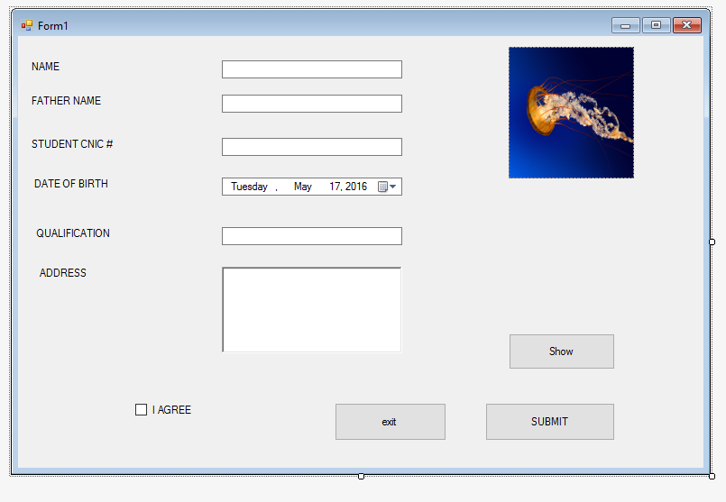

using System;

using System.Collections.Generic;

using System.ComponentModel;

using System.Data;

using System.Drawing;

using System.Linq;

using System.Text;

using System.Threading.Tasks;

using System.Windows.Forms;

namespace ClassLab

{

publicpartialclassForm1 : Form

{

public Form1()

{

InitializeComponent();

}

privatevoid button1_Click(object sender, EventArgs e)

{

Form2 a = newForm2();

a.Show();

}

privatevoid button2_Click(object sender, EventArgs e)

{

Form1 f1 = newForm1();

this.Close();

}

privatevoid button3_Click(object sender, EventArgs e)

{

Form2 x = newForm2();

x.Show();

}

}

}

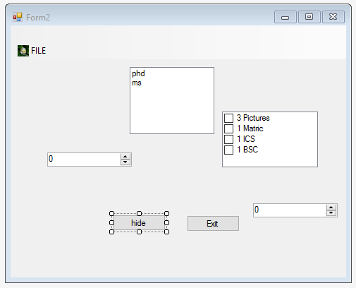

using System;

using System.Collections.Generic;

using System.ComponentModel;

using System.Data;

using System.Drawing;

using System.Linq;

using System.Text;

using System.Threading.Tasks;

using System.Windows.Forms;

namespace ClassLab

{

publicpartialclassForm2 : Form

{

public Form2()

{

InitializeComponent();

}

privatevoid button1_Click(object sender, EventArgs e)

{

Form3 F3 = newForm3();

F3.Show();

}

privatevoid button2_Click(object sender, EventArgs e)

{

this.Hide();

}

}

}

**HOW TO DOWNLOAD IN WINDOW FORM IN C#**

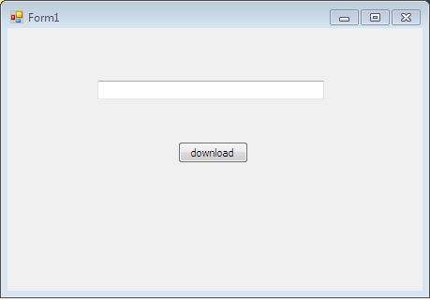

using System;

using System.Collections.Generic;

using System.ComponentModel;

using System.Data;

using System.Drawing;

using System.Linq;

using System.Net;

using System.Text;

using System.Threading.Tasks;

using System.Windows.Forms;

namespace WindowsFormsApplication5

{

publicpartialclassForm1 : Form

{

WebClient wc = newWebClient();

public Form1()

{

InitializeComponent();

}

privatevoid Form1_Load(object sender, EventArgs e)

{

}

privatevoid button1_Click(object sender, EventArgs e)

{

wc.DownloadFileCompleted += newAsyncCompletedEventHandler(FileCompleted);

Uri imageUri = newUri(textBox1.Text);

wc.DownloadFileAsync(imageUri, "image.jpg");

}

privatevoid FileCompleted(object sender,AsyncCompletedEventArgs e)

{

MessageBox.Show("completed");

}

}

}

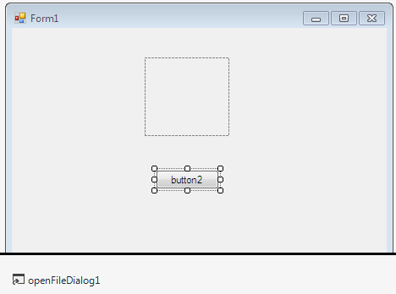

**UPLOAD CODE IN WINDOW FORM IN C#**

privatevoid button2_Click(object sender, EventArgs e)

{

OpenFileDialog opd = newOpenFileDialog();

opd.Filter = "images only.|* .jpg; *.jpeg; *.png; *.gif;";

DialogResult dr = opd.ShowDialog();

pictureBox1.Image = Image.FromFile(opd.FileName);

}

**Different Validations on different Tools of Windows Form**

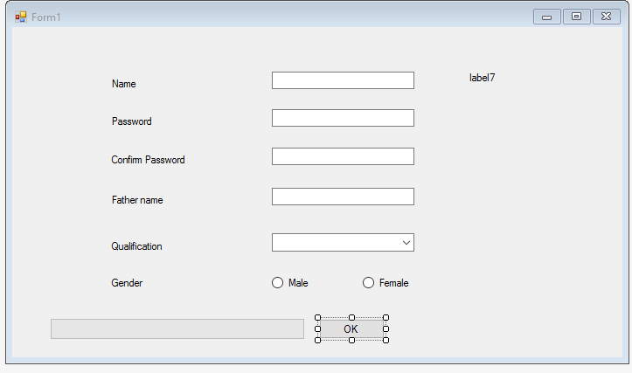

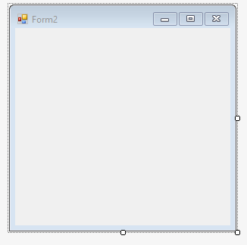

using System;

using System.Collections.Generic;

using System.ComponentModel;

using System.Data;

using System.Drawing;

using System.Linq;

using System.Text;

using System.Threading.Tasks;

using System.Text.RegularExpressions;

using System.Windows.Forms;

namespace WindowsFormsApplication1

{

publicpartialclassForm1 : Form

{

int second = 0;

public Form1()

{

InitializeComponent();

}

privatevoid button1_Click(object sender, EventArgs e)

{

int i;

progressBar1.Minimum = 0;

progressBar1.Maximum = 200;

for (i = 0; i <= 200; i++)

{

progressBar1.Value = i;

}

if (textBox1.Text == string.Empty)

{

MessageBox.Show("Name Feild is Empty!!!!");

}

elseif (textBox2.Text == string.Empty)

{

MessageBox.Show("Password Feild is Empty!!!!");

}

elseif (textBox2.Text != textBox3.Text)

{

MessageBox.Show("Password Mis Match Re Enter Care Fully!!!!");

}

elseif (textBox4.Text == string.Empty)

{

MessageBox.Show("Father Name Feild is Empty!!!!");

}

elseif(comboBox1.SelectedIndex == -1)

{

MessageBox.Show("Qualification Feild Should not be Empty!!!!");

}

elseif (!radioButton1.Checked && !radioButton2.Checked)

{

MessageBox.Show("Please check one radio button!");

}

else

{

Form2 a = newForm2();

a.Show();

}

}

privatevoid textBox1_TextChanged(object sender, EventArgs e)

{

}

privatevoid Form1_Load(object sender, EventArgs e)

{

timer1.Interval = 1000;

timer1.Start();

}

privatevoid timer1_Tick(object sender, EventArgs e)

{

label7.Text = DateTime.Now.ToLongTimeString();

// label7.Text = DateTime.Now.ToString();

second = second + 1;

if (second >= 120)

{

timer1.Stop();

MessageBox.Show("Exiting from Timer....");

}

}

privatevoid textBox1_Validating(object sender, CancelEventArgs e)

{

}

privatevoid textBox1_Validating(object sender, KeyPressEventArgs e)

{

if ((e.KeyChar >= 65 && e.KeyChar <= 90) || (e.KeyChar >= 97 && e.KeyChar <= 122) || e.KeyChar == 32 || e.KeyChar == 8)

{

}

else

{

MessageBox.Show("accept only characters");

}

}

privatevoid textBox4_validating(object sender, KeyPressEventArgs e)

{

if ((e.KeyChar >= 65 && e.KeyChar <= 90) || (e.KeyChar >= 97 && e.KeyChar <= 122) || e.KeyChar == 32 || e.KeyChar == 8)

{

}

else

{

MessageBox.Show("accept only characters");

}

}

privatevoid textBox2_validating(object sender, CancelEventArgs e)

{

RegExp(@"^[A-Za-z]{1}[A-Za-z0-9]{7,12}$", textBox2, label2, "Password : ");

}

publicvoid RegExp(string re, TextBox tb, Label la, string s)

{

Regex a = newRegex(re);

if (a.IsMatch(tb.Text))

{

// pb.Image = Properties.Resources.animated_computer_image_0025;

la.ForeColor = Color.Yellow;

la.Text = s + "valid";

}

else

{

// pb.Image = Properties.Resources.animated_computer_image_0432;

la.ForeColor = Color.Red;

la.Text = s + "invalid";

}

}

privatevoid textBox2_validating(object sender, KeyPressEventArgs e)

{

if(textBox2.TextLength < 3)

{

label8.ForeColor = Color.Red;

label8.Text = "Password is Very Weak";

}

elseif(textBox2.TextLength <= 8)

{

label8.ForeColor = Color.Blue;

label8.Text = "Password is Average";

}

else

{

label8.ForeColor = Color.Green;

label8.Text = "Password is Strong";

}

}

privatevoid label7_Click(object sender, EventArgs e)

{

}

}

}

**Menu Strip in Windows Form of C#**

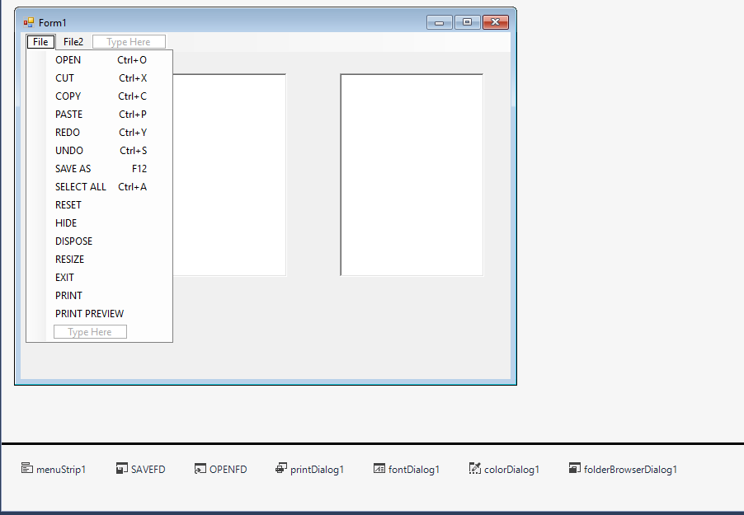

using System;

using System.Collections.Generic;

using System.ComponentModel;

using System.Data;

using System.Drawing;

using System.Linq;

using System.Text;

using System.Threading.Tasks;

using System.Windows.Forms;

namespace MenuStrip

{

publicpartialclassForm1 : Form

{

public Form1()

{

InitializeComponent();

}

privatevoid cUTToolStripMenuItem_Click(object sender, EventArgs e)

{

richTextBox1.Cut();

}

privatevoid cOPYToolStripMenuItem_Click(object sender, EventArgs e)

{

richTextBox1.Copy();

}

privatevoid pASTEToolStripMenuItem_Click(object sender, EventArgs e)

{

richTextBox2.Paste();

}

privatevoid rESETToolStripMenuItem_Click(object sender, EventArgs e)

{

richTextBox1.ResetText();

}

privatevoid hIDEToolStripMenuItem_Click(object sender, EventArgs e)

{

richTextBox1.Hide();

}

privatevoid dISPOSEToolStripMenuItem_Click(object sender, EventArgs e)

{

richTextBox1.Dispose();

}

privatevoid sELECTALLToolStripMenuItem_Click(object sender, EventArgs e)

{

richTextBox1.SelectAll();

}

privatevoid eXITToolStripMenuItem_Click(object sender, EventArgs e)

{

this.Close();

}

privatevoid rESIZEToolStripMenuItem_Click(object sender, EventArgs e)

{

richTextBox1.ResetText();

}

privatevoid sAVEASToolStripMenuItem_Click(object sender, EventArgs e)

{

string SAVE_FILE = "";

SAVEFD.InitialDirectory = "c:";

SAVEFD.Title = "Save a Text File";

SAVEFD.FileName = "";

SAVEFD.Filter = "Text Files| *.txt | All Files | *.*";

if (SAVEFD.ShowDialog() != DialogResult.Cancel)

{

SAVE_FILE = SAVEFD.FileName;

richTextBox1.SaveFile(SAVE_FILE,RichTextBoxStreamType.PlainText);

}

}

privatevoid toolStripMenuItem2_Click(object sender, EventArgs e)

{

richTextBox1.Undo();

}

privatevoid toolStripMenuItem1_Click(object sender, EventArgs e)

{

richTextBox1.Redo();

}

privatevoid oPENToolStripMenuItem_Click(object sender, EventArgs e)

{

string Chosen_FILE = "";

OPENFD.InitialDirectory = "c:";

OPENFD.Title = "Open a text file";

OPENFD.FileName = "";

OPENFD.Filter = "Text Files|*.txt| ALL FILES |* .*";

if (OPENFD.ShowDialog() != DialogResult.Cancel)

{

Chosen_FILE = OPENFD.FileName;

richTextBox1.LoadFile(Chosen_FILE, RichTextBoxStreamType.PlainText);

}

}

privatevoid pRINTToolStripMenuItem_Click(object sender, EventArgs e)

{

PrintDialog pd = newPrintDialog();

pd.ShowDialog();

}

privatevoid pRINTPREVIEWToolStripMenuItem_Click(object sender, EventArgs e)

{

PrintPreviewDialog pp = newPrintPreviewDialog();

pp.ShowDialog();

}

privatevoid deSelectAllToolStripMenuItem_Click(object sender, EventArgs e)

{

richTextBox1.DeselectAll();

}

privatevoid refreshToolStripMenuItem_Click(object sender, EventArgs e)

{

Form1 a = newForm1();

a.Refresh();

}

privatevoid newToolStripMenuItem_Click(object sender, EventArgs e)

{

Form1 b = newForm1();

b.Show();

}

privatevoid fontToolStripMenuItem_Click(object sender, EventArgs e)

{

FontDialog pd = newFontDialog();

pd.ShowDialog();

}

privatevoid colorDialogToolStripMenuItem_Click(object sender, EventArgs e)

{

ColorDialog cd = newColorDialog();

cd.ShowDialog();

}

privatevoid folderBrowserToolStripMenuItem_Click(object sender, EventArgs e)

{

FolderBrowserDialog fd = newFolderBrowserDialog();

fd.ShowDialog();

}

privatevoid cLOSEToolStripMenuItem_Click(object sender, EventArgs e)

{

this.Close();

}

}

}

**Password and Confirm Password (Reguler Expression) if Password is Same Open New Windows Form in C#**

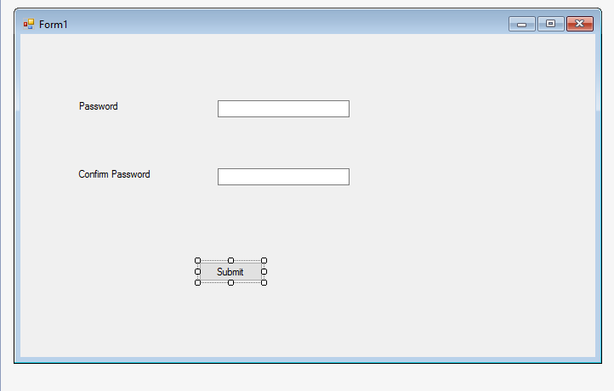

using System;

using System.Collections.Generic;

using System.ComponentModel;

using System.Data;

using System.Drawing;

using System.Linq;

using System.Text;

using System.Threading.Tasks;

using System.Windows.Forms;

using System.Text.RegularExpressions;

namespace Password1

{

publicpartialclassForm1 : Form

{

public Form1()

{

InitializeComponent();

}

privatevoid textBox1_validating(object sender, CancelEventArgs e)

{

RegExp(@"^[A-Za-z0-9]{8,12}$",textBox1,label1,"Password : ");

if(textBox1.Text==string.Empty)

{

MessageBox.Show("Password Feild is Empty!!!!!");

}

}

privatevoid textBox2_validating(object sender, CancelEventArgs e)

{

RegExp(@"^[\w]{8,12}$", textBox2, label2, "Confirm Password : ");

if (textBox2.Text == string.Empty)

{

MessageBox.Show("Confirm Password Feild is empty");

}

}

publicvoid RegExp(string re, TextBox tb,Label la,string s)

{

Regex a = newRegex(re);

if (a.IsMatch(tb.Text))

{

// pb.Image = Properties.Resources.animated_computer_image_0025;

la.ForeColor = Color.Blue;

la.Text = s + "valid";

}

else

{

// pb.Image = Properties.Resources.animated_computer_image_0432;

la.ForeColor = Color.Red;

la.Text = s + "invalid";

}

}

privatevoid Submit(object sender, EventArgs e)

{

}

privatevoid button1_Click(object sender, EventArgs e)

{

if(textBox1.Text == textBox2.Text)

{

Form2 n = newForm2();

n.Show();

}

else

{

MessageBox.Show("Password Mismatch Re Enter CareFully Paglae!!!");

}

}

privatevoid textBox1_TextChanged(object sender, EventArgs e)

{

}

}

}

**Progress Bar with Timer including Start and Stop Button inWindows Form in C#**

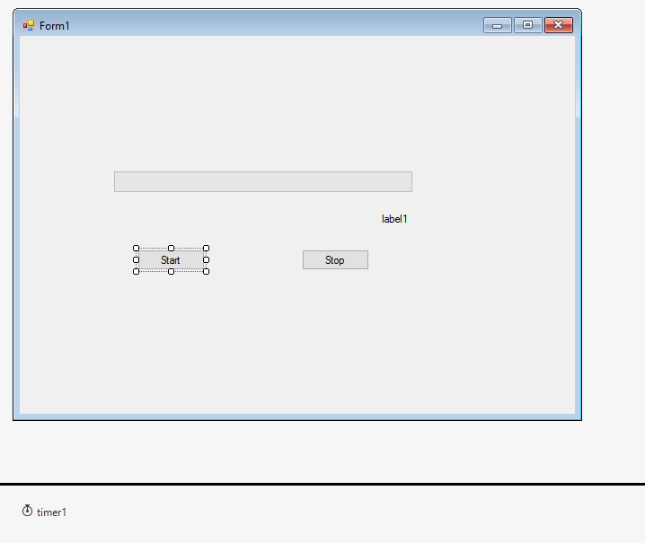

using System;

using System.Collections.Generic;

using System.ComponentModel;

using System.Data;

using System.Drawing;

using System.Linq;

using System.Text;

using System.Threading.Tasks;

using System.Windows.Forms;

namespace Timer_ProgressBar

{

publicpartialclassForm1 : Form

{

public Form1()

{

InitializeComponent();

}

privatevoid button1_Click(object sender, EventArgs e)

{

timer1.Enabled = true;

}

privatevoid button2_Click(object sender, EventArgs e)

{

timer1.Enabled = false;

}

privatevoid timer1_tick(object sender, EventArgs e)

{

progressBar1.Increment(1);

label1.Text = progressBar1.Value.ToString() + "%";

}

}

}

**Back Ground Worker with Progress Bar in Windows Form in C#**

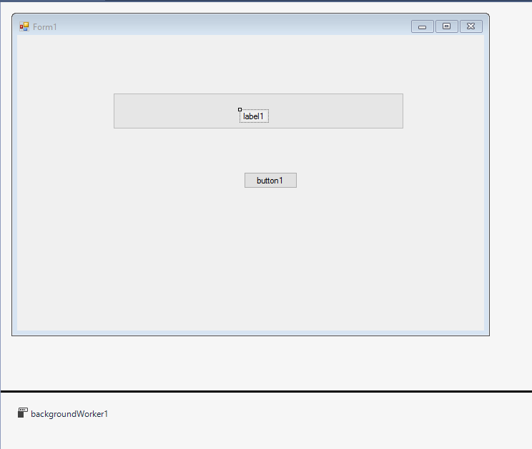

using System;

using System.Collections.Generic;

using System.ComponentModel;

using System.Data;

using System.Drawing;

using System.Linq;

using System.Text;

using System.Threading.Tasks;

using System.Windows.Forms;

using System.Threading;

namespace WindowsFormsApplication4

{

publicpartialclassForm1 : Form

{

public Form1()

{

InitializeComponent();

}

privatevoid progressBar1_Click(object sender, EventArgs e)

{

}

privatevoid backgroundWorker1_ProgressChanged(object sender, ProgressChangedEventArgs e)

{

progressBar1.Value = e.ProgressPercentage;

this.Text = e.ProgressPercentage.ToString() + " %";

label2.Text = e.ProgressPercentage.ToString() + " %";

if (progressBar1.Value <= 25)

{

progressBar1.ForeColor = Color.Red;

//this.BackColor = Color.White;

}

elseif (progressBar1.Value <= 50)

{

progressBar1.ForeColor = Color.LightGreen;

//this.BackColor = Color.LightGreen;

}

elseif (progressBar1.Value <= 80)

{

progressBar1.ForeColor = Color.GreenYellow;

// this.BackColor = Color.GreenYellow;

}

else

{

progressBar1.ForeColor = Color.LawnGreen;

//this.BackColor = Color.LawnGreen;

}

}

privatevoid backgroundWorker1_DoWork(object sender, DoWorkEventArgs e)

{

int i;

for ( i = 0; i <= 100; i++)

{

Thread.Sleep(100);

backgroundWorker1.ReportProgress(i);

}

}

privatevoid backgroundWorker1_RunWorkerCompleted(object sender, RunWorkerCompletedEventArgs e)

{

label2.Visible = true;

}

privatevoid button1_Click(object sender, EventArgs e)

{

backgroundWorker1.RunWorkerAsync();

}

}

}

**Stop Watch using Timer with Start and Stop Button Displays Current Date and Time Windows Form in C#**

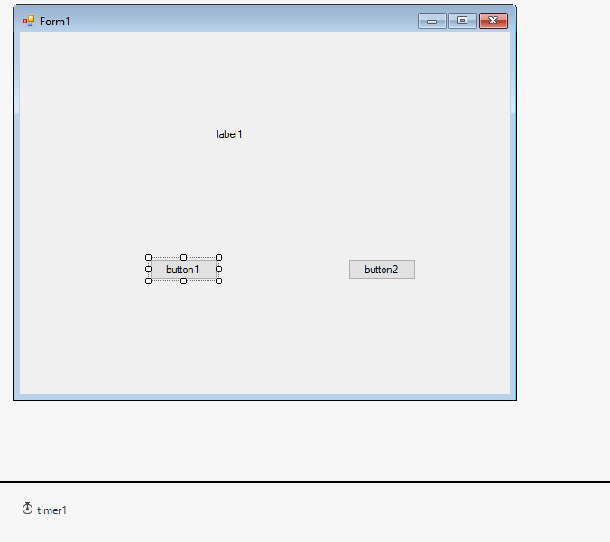

using System;

using System.Collections.Generic;

using System.ComponentModel;

using System.Data;

using System.Drawing;

using System.Linq;

using System.Text;

using System.Threading.Tasks;

using System.Windows.Forms;

namespace StopWatch

{

publicpartialclassForm1 : Form

{

public Form1()

{

InitializeComponent();

}

privatevoid button1_Click(object sender, EventArgs e)

{

label1.Text = "00:00:00";

timer1.Start();

int second = 0;

second = second + 1;

}

privatevoid button2_Click(object sender, EventArgs e)

{

timer1.Stop();

}

privatevoid timer1_Tick(object sender, EventArgs e)

{

label1.Text = DateTimeOffset.Now.ToString();

}

}

}

**Calculator with Text Boxes and Buttons Windows Form of C#**

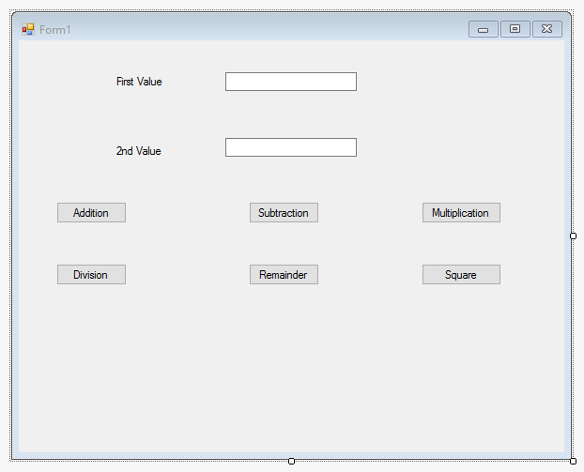

using System;

using System.Collections.Generic;

using System.ComponentModel;

using System.Data;

using System.Drawing;

using System.Linq;

using System.Text;

using System.Threading.Tasks;

using System.Windows.Forms;

namespace TextBox_Calculator

{

publicpartialclassForm1 : Form

{

public Form1()

{

InitializeComponent();

}

publicvoid textBox1_TextChanged(object sender, EventArgs e)

{

}

publicvoid textBox2_TextChanged(object sender, EventArgs e)

{

}

privatevoid button1_Click(object sender, EventArgs e)

{

int a = int.Parse(textBox1.Text);

int b = int.Parse(textBox2.Text);

int add = a + b;

MessageBox.Show("Addition = "+add.ToString());

}

privatevoid button2_Click(object sender, EventArgs e)

{

int a = int.Parse(textBox1.Text);

int b = int.Parse(textBox2.Text);

int sub = a - b;

MessageBox.Show("Subtraction = " + sub.ToString());

}

privatevoid button3_Click(object sender, EventArgs e)

{

int a = int.Parse(textBox1.Text);

int b = int.Parse(textBox2.Text);

int mul = a * b;

MessageBox.Show("Multiplication = " + mul.ToString());

}

privatevoid button4_Click(object sender, EventArgs e)

{

int a = int.Parse(textBox1.Text);

int b = int.Parse(textBox2.Text);

int div = a / b;

MessageBox.Show("Division = " + div.ToString());

}

privatevoid button5_Click(object sender, EventArgs e)

{

int a = int.Parse(textBox1.Text);

int b = int.Parse(textBox2.Text);

int rem = a % b;

MessageBox.Show("Remainder = " + rem.ToString());

}

privatevoid button6_Click(object sender, EventArgs e)

{

int a = int.Parse(textBox1.Text);

int sq = a * a;

MessageBox.Show("Square = " + sq.ToString());

}

}

}

**Different Validations (Regular Expression) Windows Form of C#**

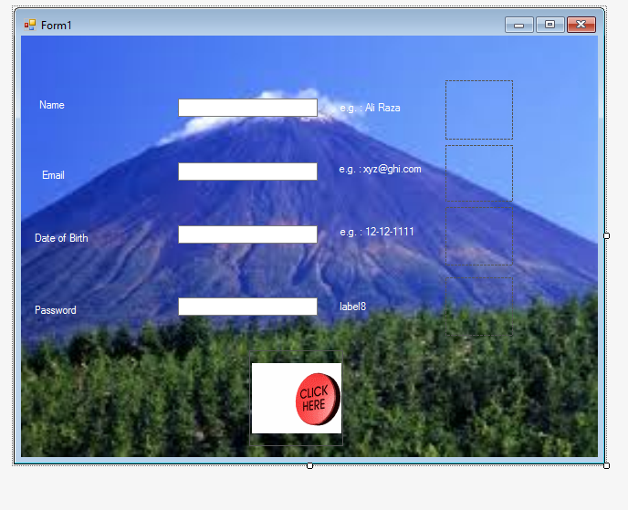

using System;

using System.Collections.Generic;

using System.ComponentModel;

using System.Data;

using System.Drawing;

using System.Linq;

using System.Text;

using System.Threading.Tasks;

using System.Text.RegularExpressions;

using System.Windows.Forms;

namespace WindowsFormsApplication3

{

publicpartialclassForm1 : Form

{

public Form1()

{

InitializeComponent();

}

privatevoid button1_Click(object sender, EventArgs e)

{

RegExp(@"^[A-Za-z\s]{1,40}$",textBox1, pictureBox1,label1, "Name: ");

RegExp(@"^([\w]+)@([\w]+)\.([\w]+)$", textBox2, pictureBox2, label2, "Email: ");

RegExp(@"[0-3]{1}[0-9]{1}\-[0-1]{1}[0-9]{1}\-[0-9]{4}$", textBox3, pictureBox3, label3, "D.O.B.");

RegExp(@"^[A-Za-z]{1}[A-Za-z0-9]{7,19}$", textBox4, pictureBox4, label4, "Password: ");

if(textBox1.Text != string.Empty && textBox2.Text != string.Empty && textBox3.Text != string.Empty && textBox4.Text != string.Empty)

{

Form2 a = newForm2();

a.Show();

}

}

privatevoid textbox1_validating(object sender, CancelEventArgs e)

{

if (textBox1.Text == string.Empty)

{

MessageBox.Show("Name Feild is empty");

}

}

privatevoid textbox2_validating(object sender, CancelEventArgs e)

{

if (textBox2.Text == string.Empty)

{

MessageBox.Show("Email Feild is empty");

}

}

privatevoid textbox3_validating(object sender, CancelEventArgs e)

{

if (textBox3.Text == string.Empty)

{

MessageBox.Show("Date of Birth field is empty");

}

}

privatevoid textbox4_validating(object sender, CancelEventArgs e)

{

if (textBox4.Text == string.Empty)

{

MessageBox.Show("Password field is empty");

}

}

publicvoid RegExp(string re, TextBox tb, PictureBox pb, Label la, string s)

{

Regex a = newRegex(re);

if (a.IsMatch(tb.Text))

{

pb.Image = Properties.Resources.animated_computer_image_0025;

la.ForeColor = Color.Yellow;

la.Text = s + "valid";

}

else

{

pb.Image = Properties.Resources.animated_computer_image_0432;

la.ForeColor = Color.Red;

la.Text = s + "invalid";

}

}

}

}

**Calculator Producing Result in 3rd TextBox Windows Form of C#**

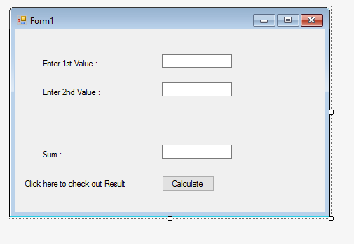

using System;

using System.Collections.Generic;

using System.ComponentModel;

using System.Data;

using System.Drawing;

using System.Linq;

using System.Text;

using System.Threading.Tasks;

using System.Windows.Forms;

namespace Calc

{

publicpartialclassForm1 : Form

{

public Form1()

{

InitializeComponent();

}

privatevoid button1_Click(object sender, EventArgs e)

{

int a = int.Parse(textBox1.Text);

int b = int.Parse(textBox2.Text);

int c = a + b;

textBox3.Text = c.ToString();

}

}

}

**Simple date Entery Using if Else Windows Form of C#**

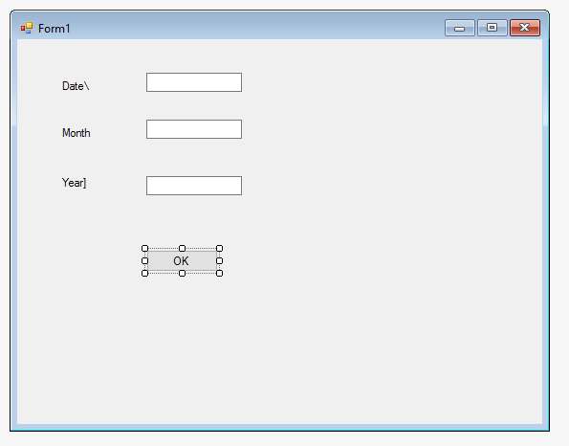

using System;

using System.Collections.Generic;

using System.ComponentModel;

using System.Data;

using System.Drawing;

using System.Linq;

using System.Text;

using System.Threading.Tasks;

using System.Windows.Forms;

namespace Date

{

publicpartialclassForm1 : Form

{

public Form1()

{

InitializeComponent();

}

privatevoid textBox1_TextChanged(object sender, EventArgs e)

{

}

privatevoid textBox2_TextChanged(object sender, EventArgs e)

{

}

privatevoid button1_Click(object sender, EventArgs e)

{

int d = int.Parse(textBox1.Text);

int m = int.Parse(textBox2.Text);

int y = int.Parse(textBox3.Text);

if (d >= 1 && d <= 31)

{

if (m >= 1 && m <= 12)

{

if (y >= 2000 && y <= 2020)

{

MessageBox.Show("Date is Entered Fully Correctly!!!!");

}

else

{

MessageBox.Show("Year is not Entered Correctly!!!!");

}

}

else

{

MessageBox.Show("Month is not Entered Correctly!!!!");

}

}

else

{

MessageBox.Show("Date is not Entered Correctly!!!!");

}

}

}

}

**Form will Close After Specific Time Windows Form of C#**

using System;

using System.Collections.Generic;

using System.ComponentModel;

using System.Data;

using System.Drawing;

using System.Linq;

using System.Text;

using System.Threading.Tasks;

using System.Windows.Forms;

namespace FOrm_Timer_Close

{

publicpartialclassForm1 : Form

{

public Form1()

{

InitializeComponent();

}

privatevoid timer1_Tick(object sender, EventArgs e)

{

MessageBox.Show("Form is Going to be Close!!!!!");

this.Close();

}

privatevoid Form1_Load(object sender, EventArgs e)

{

Timer a = newTimer();

a.Interval = (10*1000);

a.Tick += newEventHandler(timer1_Tick);

a.Start();

}

}

}

**KeyPress Validation Windows Form of C#**

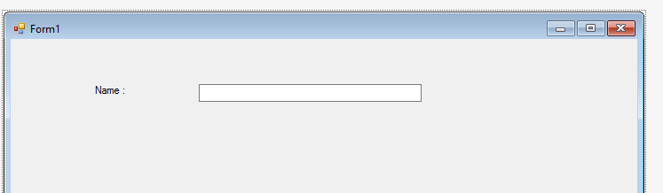

using System;

using System.Collections.Generic;

using System.ComponentModel;

using System.Data;

using System.Drawing;

using System.Linq;

using System.Text;

using System.Threading.Tasks;

using System.Windows.Forms;

namespace Keypress_Validations

{

publicpartialclassForm1 : Form

{

public Form1()

{

InitializeComponent();

}

privatevoid textBox1_Key(object sender, KeyPressEventArgs e)

{

if(e.KeyChar >=65 && e.KeyChar <=90 || e.KeyChar >=97 && e.KeyChar <= 122 || e.KeyChar == 8 || e.KeyChar == 32)

{

}

else

{

MessageBox.Show("Wrong Entery!!!!!");

}

}

privatevoid textBox1_TextChanged(object sender, EventArgs e)

{

}

}

}

**Mini Note Pad Windows Form of C#**

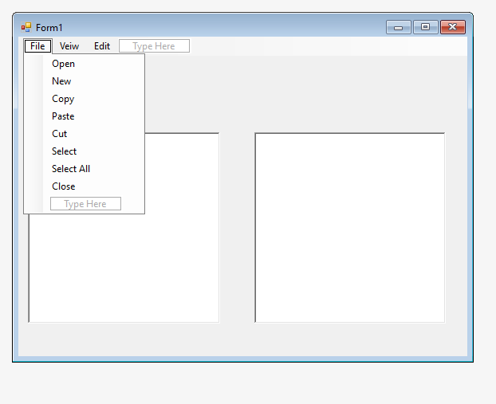

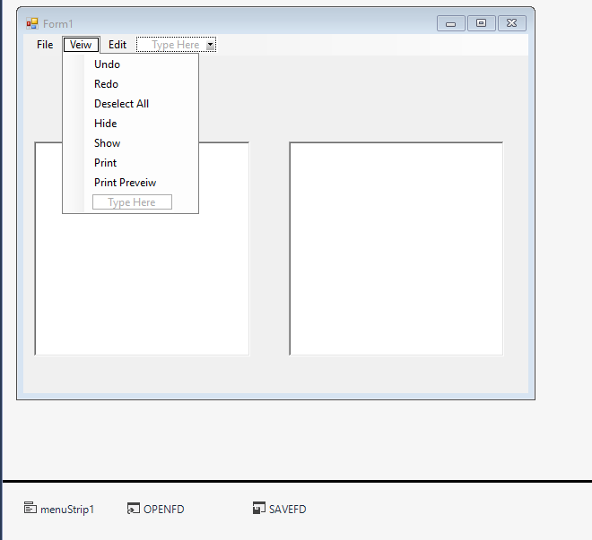

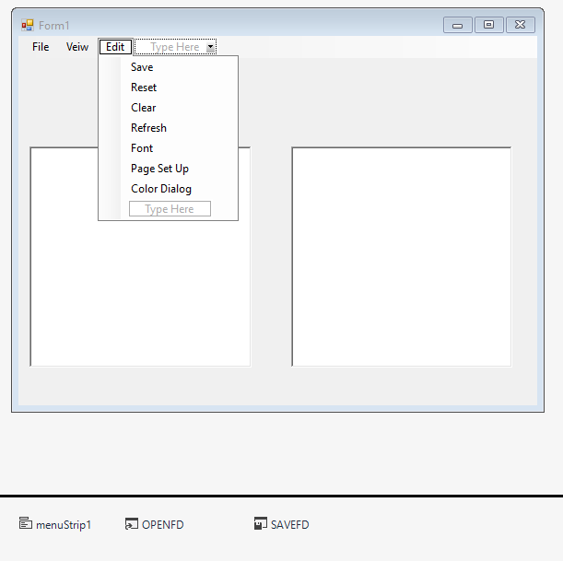

using System;

using System.Collections.Generic;

using System.ComponentModel;

using System.Data;

using System.Drawing;

using System.Linq;

using System.Text;

using System.Threading.Tasks;

using System.Windows.Forms;

namespace Note_Pad

{

publicpartialclassForm1 : Form

{

public Form1()

{

InitializeComponent();

}

privatevoid copyToolStripMenuItem_Click(object sender, EventArgs e)

{

richTextBox1.Copy();

}

privatevoid pasteToolStripMenuItem_Click(object sender, EventArgs e)

{

richTextBox1.Paste();

}

privatevoid cutToolStripMenuItem_Click(object sender, EventArgs e)

{

richTextBox1.Cut();

}

privatevoid selectToolStripMenuItem_Click(object sender, EventArgs e)

{

richTextBox1.Select();

}

privatevoid selectAllToolStripMenuItem_Click(object sender, EventArgs e)

{

richTextBox1.SelectAll();

}

privatevoid closeToolStripMenuItem_Click(object sender, EventArgs e)

{

this.Close();

}

privatevoid undoToolStripMenuItem_Click(object sender, EventArgs e)

{

richTextBox1.Undo();

}

privatevoid redoToolStripMenuItem_Click(object sender, EventArgs e)

{

richTextBox1.Redo();

}

privatevoid newToolStripMenuItem1_Click(object sender, EventArgs e)

{

}

privatevoid newToolStripMenuItem_Click(object sender, EventArgs e)

{

Form1 a = newForm1();

a.Show();

}

privatevoid hideToolStripMenuItem_Click(object sender, EventArgs e)

{

richTextBox1.Hide();

}

privatevoid showToolStripMenuItem_Click(object sender, EventArgs e)

{

richTextBox1.Show();

}

privatevoid printToolStripMenuItem_Click(object sender, EventArgs e)

{

PrintDialog pd = newPrintDialog();

pd.ShowDialog();

}

privatevoid printPreveiwToolStripMenuItem_Click(object sender, EventArgs e)

{

PrintPreviewDialog ppd = newPrintPreviewDialog();

ppd.ShowDialog();

}

privatevoid resetToolStripMenuItem_Click(object sender, EventArgs e)

{

richTextBox1.ResetText();

}

privatevoid clearToolStripMenuItem_Click(object sender, EventArgs e)

{

richTextBox1.Clear();

}

privatevoid refreshToolStripMenuItem_Click(object sender, EventArgs e)

{

richTextBox1.Refresh();

}

privatevoid fontToolStripMenuItem_Click(object sender, EventArgs e)

{

FontDialog fd = newFontDialog();

fd.ShowDialog();

}

privatevoid pageSetUpToolStripMenuItem_Click(object sender, EventArgs e)

{

FolderBrowserDialog fbd = newFolderBrowserDialog();

fbd.ShowDialog();

}

privatevoid colorDialogToolStripMenuItem_Click(object sender, EventArgs e)

{

ColorDialog cd = newColorDialog();

cd.ShowDialog();

}

privatevoid openToolStripMenuItem_Click(object sender, EventArgs e)

{

string Chooen_File = "";

OPENFD.InitialDirectory = "c:";

OPENFD.Title = "Open File :";

OPENFD.FileName = "";

OPENFD.Filter = "Text Files|*.txt| All Files | *.*";

if(OPENFD.ShowDialog() != DialogResult.Cancel)

{

Chooen_File = OPENFD.FileName;

richTextBox1.LoadFile(Chooen_File, RichTextBoxStreamType.PlainText);

}

}

privatevoid saveToolStripMenuItem_Click(object sender, EventArgs e)

{

string Save_File = "";

SAVEFD.InitialDirectory = "c:";

SAVEFD.Title = "Save File";

SAVEFD.FileName = "";

SAVEFD.Filter = "Text File | *.txt | All Files | *.*";

if (SAVEFD.ShowDialog() != DialogResult.Cancel)

{

Save_File = SAVEFD.FileName;

richTextBox1.SaveFile(Save_File, RichTextBoxStreamType.PlainText);

}

}

}

}

**KeyPress and Reguler Expression Validation Windows Form of C#**

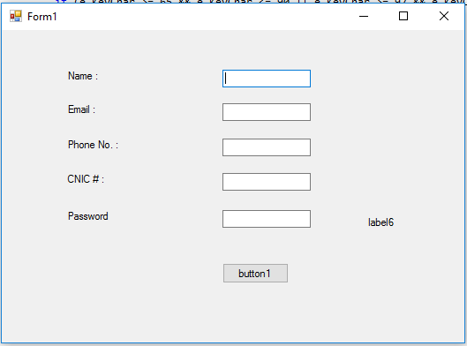

using System;

using System.Collections.Generic;

using System.ComponentModel;

using System.Data;

using System.Drawing;

using System.Linq;

using System.Text;

using System.Threading.Tasks;

using System.Windows.Forms;

using System.Text.RegularExpressions;

namespace WindowsFormsApplication1

{

publicpartialclassForm1 : Form

{

public Form1()

{

InitializeComponent();

}

privatevoid textBox1_TextChanged(object sender, EventArgs e)

{

}

privatevoid textBox1_KeyPress(object sender, KeyPressEventArgs e)

{

if(e.KeyChar >=65 && e.KeyChar <=90 || e.KeyChar >= 97 && e.KeyChar <= 122 || e.KeyChar == 8 || e.KeyChar == 32)

{

}

else

{

MessageBox.Show("Only Alphabets are Allowed!!!!");

}

}

privatevoid textBox2_Validating(object sender, CancelEventArgs e)

{

RegExp(@"^([\w]+)@([\w]+)\.([\w]+)$",textBox2,label2,"Email :");

}

privatevoid RegExp(string re, TextBox tb, Label la, string s)

{

Regex a = newRegex(re);

if(a.IsMatch(tb.Text))

{

la.Text = s + "Valid";

la.ForeColor = Color.Blue;

}

else

{

la.Text = s + "InValid";

la.ForeColor = Color.Red;

}

}

privatevoid textBox3_Validating(object sender, CancelEventArgs e)

{

RegExp(@"^[0-9]{4}\-[0-9]{7}$", textBox3, label3, "Phone No. :");

}

privatevoid textBox3_KeyPress(object sender, KeyPressEventArgs e)

{

if (e.KeyChar >= 48 && e.KeyChar <= 57 || e.KeyChar == 8 || e.KeyChar == 45)

{

}

else

{

MessageBox.Show("Only Alphabets are Allowed!!!!");

}

}

privatevoid textBox5_Validating(object sender, CancelEventArgs e)

{

RegExp(@"^[A-Za-z]{1}[A-Za-z0-9]{7}$", textBox5, label5, "Password :");

}

privatevoid textBox5_KeyPress(object sender, KeyPressEventArgs e)

{

if (e.KeyChar >= 65 && e.KeyChar <= 90 || e.KeyChar >= 97 && e.KeyChar <= 122 || e.KeyChar >= 48 && e.KeyChar <= 57 || e.KeyChar == 8 || e.KeyChar == 32)

{

if(textBox5.TextLength <3)

{

label6.ForeColor = Color.Red;

label6.Text = "Very Weak Password";

}

elseif (textBox5.TextLength < 6)

{

label6.ForeColor = Color.Blue;

label6.Text = "Normal Length Password";

}

elseif (textBox5.TextLength <= 8)

{

label6.ForeColor = Color.Green;

label6.Text = "Normal Length Password";

}

}

else

{

MessageBox.Show("Only AlphaNumerics are Allowed!!!!");

}

}

privatevoid button1_Click(object sender, EventArgs e)

{

}

}

}